ADAM MALYSZ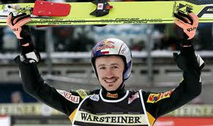
Adam Małysz Henryk (born December 3, 1977 in Wisla) - Polish ski jumper, Olympic multimedalist, the most successful jumper in the history of the World Cup individual competitions in ski jumping , race car driver. Four-time Olympic medalist, four-time individual world champion, four times (including three times in a row) the winner of the World Cup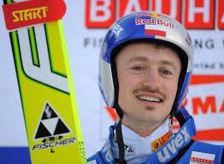

WT-Adam what do you have in yourself to be such a good jumper?
Adam: -First of all, motivation.
WT-What then is the best time to start training ski jumps?
Adam: I started jumping when I was 6 years old and now it seems to me that it was a little too early. The child should have time for a normal childhood, playing with friends, playing football or hide and seek. Another issue is the difficulty associated with the development of the child, this is also a bit of a problem. A good age is 8-10 years.
WT-What would you be doing, if not a ski jumping?
Adam: Football has always been important to me-after school I immediately went to play football with friends. However, it would be difficult to break, come somewhere above. The jumping was easier. Mountains, jumps in Wisla, it facilitated the first steps, first in Nordic combined later in the jumps. For sure it would be something related to sports.
WT-After the jumps do you find time for other sports?
Adam: It is difficult, if possible volleyball, soccer, quad biking, off-road in general.
WT How is it that you have changed and come to the discipline of motorsport?
Adam: Motorsport and automotive interested me for a long time. When I was a jumper, it was impossible even to try anything. Quite often on this subject I have spoken, so Płuciennik Raphael said, asking if I would not go with the team on the Dakar. For me, it was a shock that I did not expect. Then I was a jumper and I could not afford it. So they decided to wait. My departure from jumping planned for 2 years, and when that happened, heard from again. Then I started to prepare for a completely new adventure - to take part in Dakar.

INTERVIEW 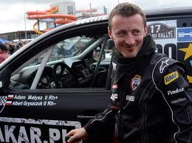WERONIKA
TYLUTKI

