My favorite sport star
My favorite sport star is Otylia Jędzejczak. She was born on 13th December on 1983 in Ruda Sląska, Poland. She is a Polish swimmer, Olympic champion, world champion, European champion, the triple world record holder, record holder in Europe, three times elected best Polish athlete. She won 14 gold medals, 9 silver medals and 6 bronze medals.

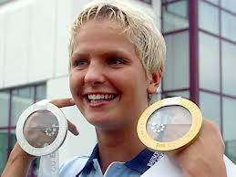

1.How old is Otylia?
a) 27
b) 31
c)29

2. How many siblings has Otylia got ?
a) two
b)one
c)three

3.What’s her favorite colour?
a) blue
b) green
c) red

4.Who is her coach?
a) Robert Kołocuga
b) Paweł Słomiński
c) Maria Lantryja

5.What age was she when she had her first swimming competition?
a) 16
b) 8
c) 11

ANSWERS:
1-c
2-b
3-a
4-b
5-b

